PRODUCT CATALOG
2020

Solar energy 3
Nr. 2008 Solar assembly solar energy- starterkit 3
Nr. 2007 photovoltaic cell 85W 3
Nr. 2009 Solar bunch + 10 photovoltaic cells + 10 Solar assembly 3
Nr. 2010 Solar bunch premium + 25 photovoltaic cell+ 25 Solar assemblies + 1x [FREE] Flower'E'power 3
Nr. 2002 Fairphone phonecase 4
Nr. 2005 Solar-Powerbank 4
Nr. 2006 Flower'E'power Solar charger 4
Nr. 2001 Fairphone 3 4
electronic data processing 4
Nr. 2003 eco- laptop 5
Nr. 2004 fridge 5
Nr. 3004 BMW i3 – Concept with eDrive 6
Nr. 3005 BMW i8 6
Nr. 3006 Tesla Roadster 2.5 6
Nr. 4001 Segway 6
Nr. 3007 Renault TWIZY Life 80 6
Vehicles 6
Nr. 3002 Renault Kangoo ZE Maxi electro car 7
Nr. 3009 Nissan e-NV200 Pro+ electro panel truck 7
Nr. 3010 Tesla Modell S 100D electro roadster 7
eco- power 8
Nr. 1001 Ökostrom1 8
Renewable energy 8
Nr. 1002 Ökostrom 2 8
Renewable energy 8
Nr. 1003 Ökostrom 3 8
Renewable energy 8
Groceries 9
Nr. 6004 BIO-MASCAO-Cokos 100g kbA milk-chocolate 9

Solar energy

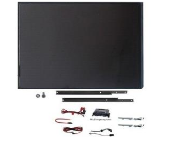 | Nr. 2008 Solar assembly  solar energy- starterkit  gross amount: € 159,84
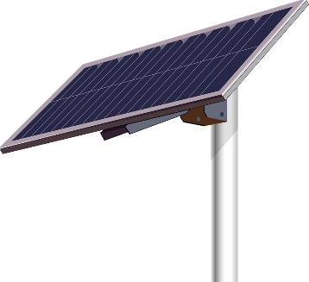 | Nr. 2007  photovoltaic cell 85W  gross amount: € 279,24
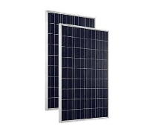 | Nr. 2009  Solar bunch + 10 photovoltaic cells + 10 Solar assembly  gross amount:  € 4.296,96
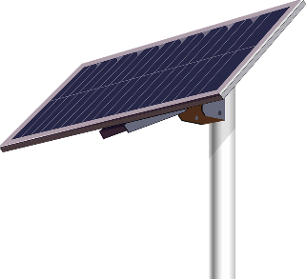  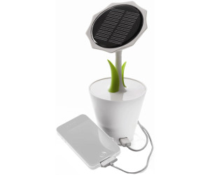 | Nr. 2010 Solar bunch premium + 25 photovoltaic cell+ 25 Solar assemblies + 1x [FREE] Flower'E'power  gross amount:  € 10.388,40

Nr. 2002 Fairphone phonecase
gross amount:
€ 24,00

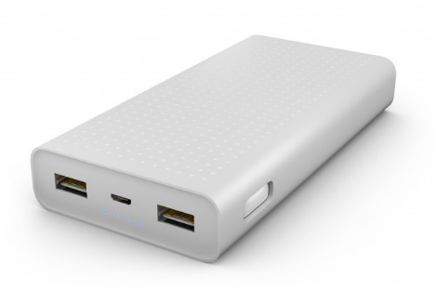 | Nr. 2005  Solar-Powerbank  gross amount:  € 25,50

Nr. 2006
Flower'E'power Solar charger
gross amount:
€ 50,99

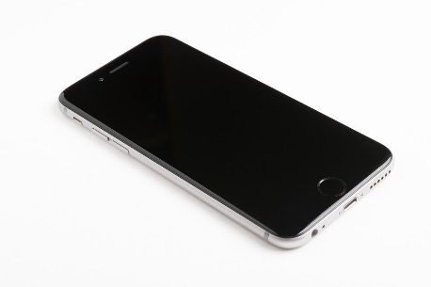 | Nr. 2001  Fairphone 3  gross amount:  € 540,00

electronic data processing

Nr. 2003
eco- laptop
gross amount: €1.018,80
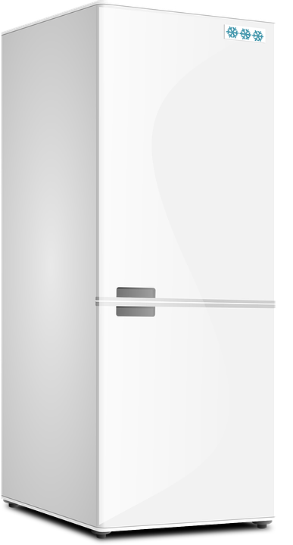 | Nr. 2004 fridge  With clean power  gross amount: € 1.799,99

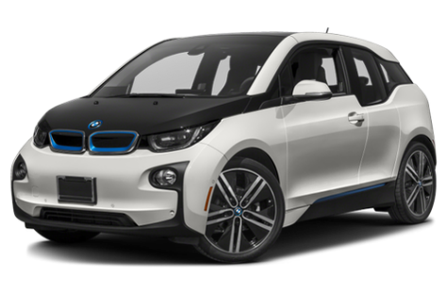 | Nr. 3004 BMW i3 – Concept with eDrive  gross amount:  € 42.840,00
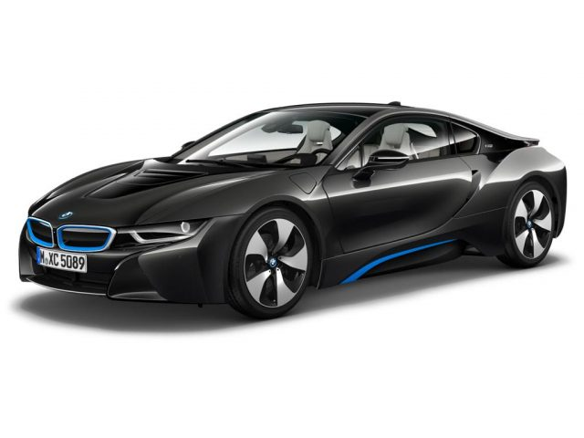 | Nr. 3005 BMW i8  electro car  gross amount:  € 164.400,00

Nr. 3006 Tesla Roadster 2.5

Electro car
gross amount:
€ 76.032,00

Nr. 4001 Segway

Electro
gross amount:
€ 359,99
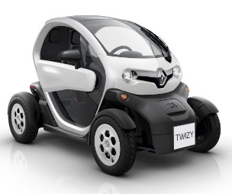 | Nr. 3007  Renault TWIZY Life 80  gross amount:  € 11.506,50

Vehicles

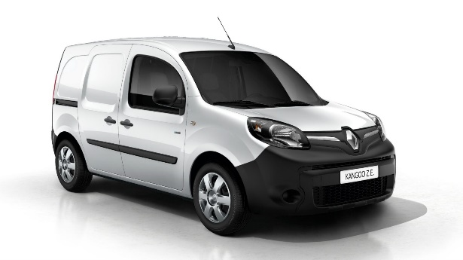 | Nr. 3002 Renault Kangoo ZE Maxi electro car  gross amount:  € 24.600,00
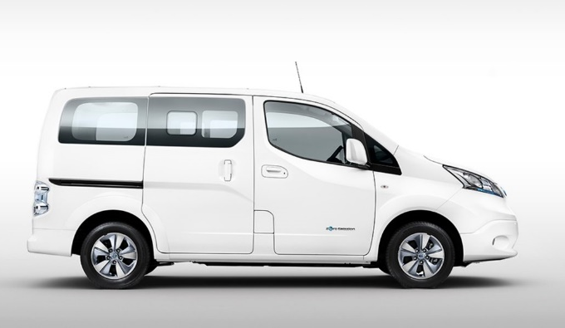 | Nr. 3009 Nissan e-NV200 Pro+ electro panel truck  gross amount:  €47.998,80
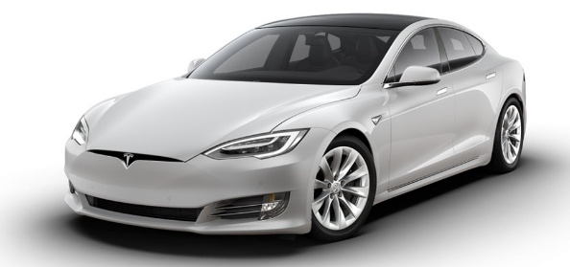 | Nr. 3010 Tesla Modell S 100D electro roadster  gross amount:  €144.000,00

eco- power
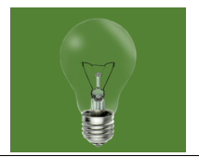 | Nr. 1001 Ökostrom1  Renewable energy  gross amount: € 360,00

Nr. 1002 Ökostrom 2

Renewable energy
gross amount:€ 420,00

Nr. 1003 Ökostrom 3

Renewable energy
gross amount: € 480,00

Groceries
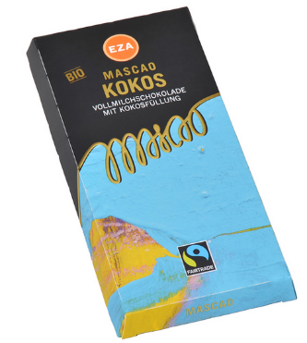 | Nr. 6004 BIO-MASCAO-Cokos 100g kbA milk-chocolate  gross amount: € 3,99

